5th Scottish International head and neck conference- Oropharyngeal cancer/Robotic surgery 16 sep 2023 Feedback
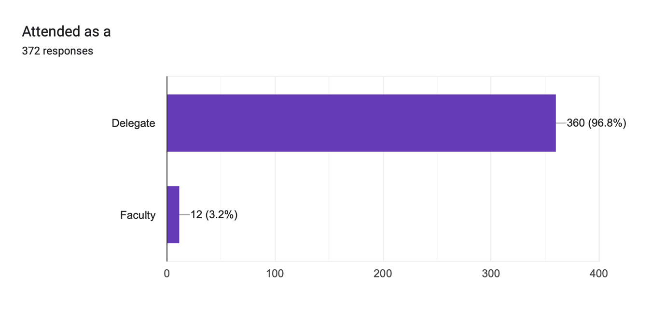
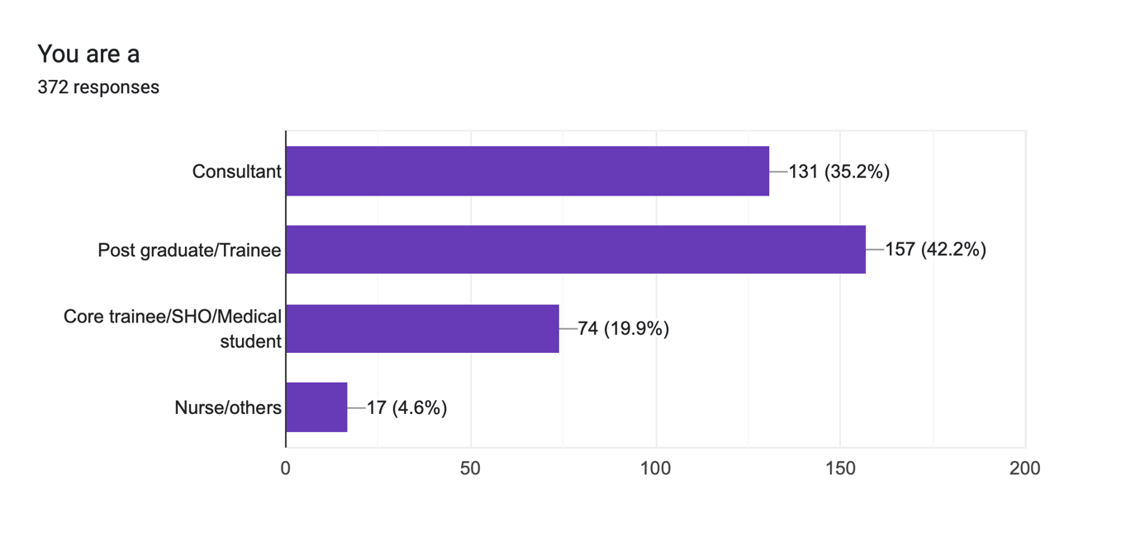
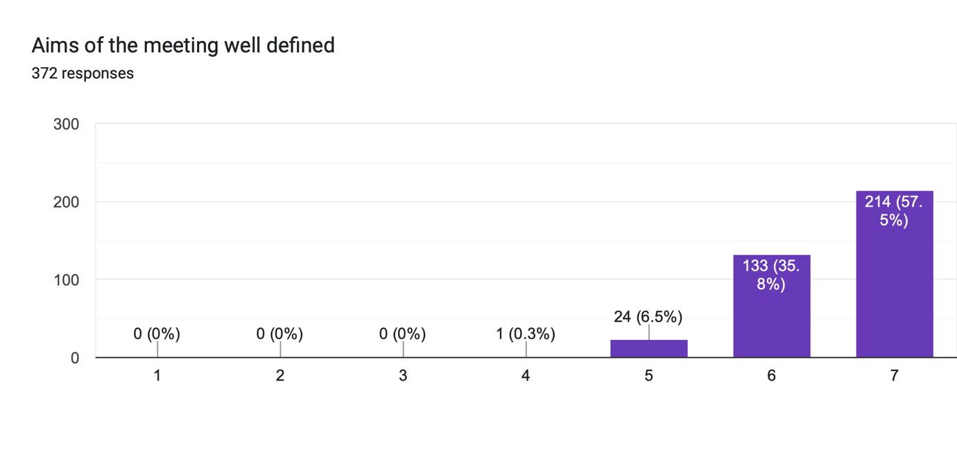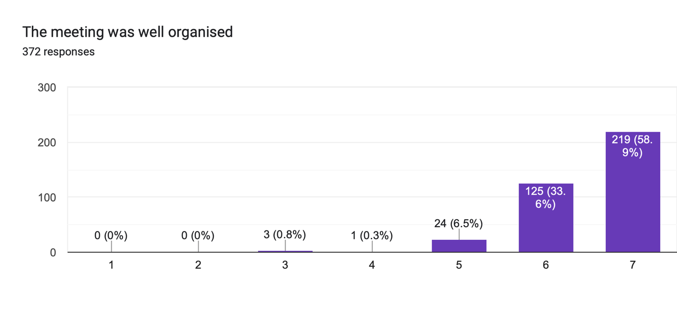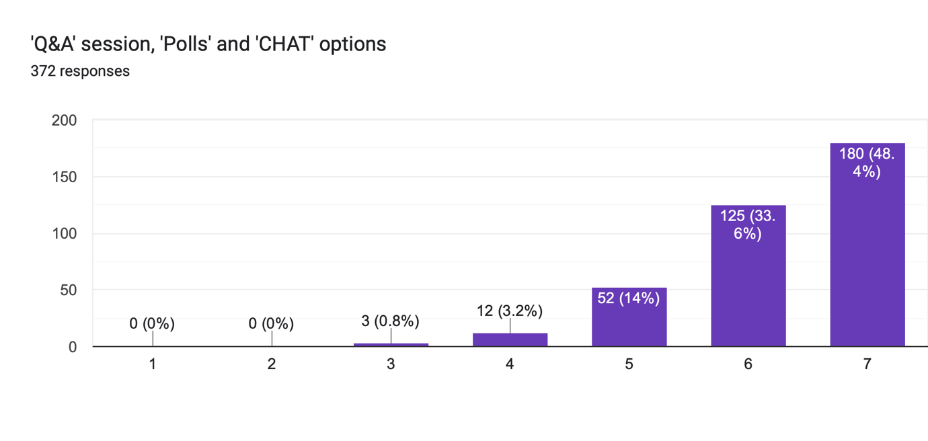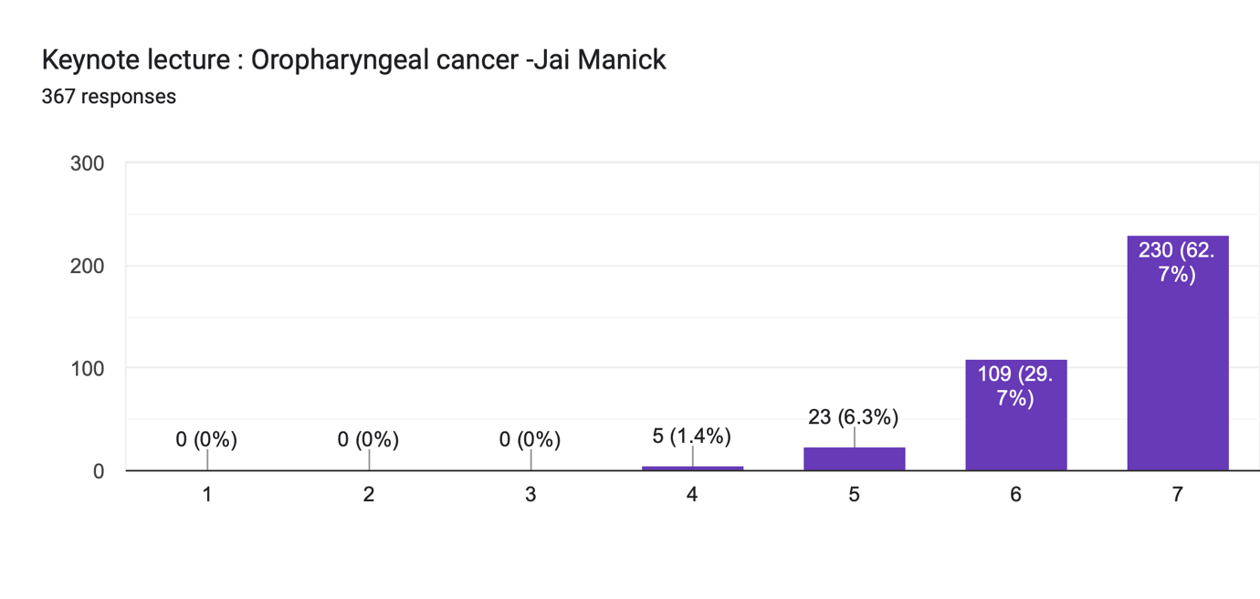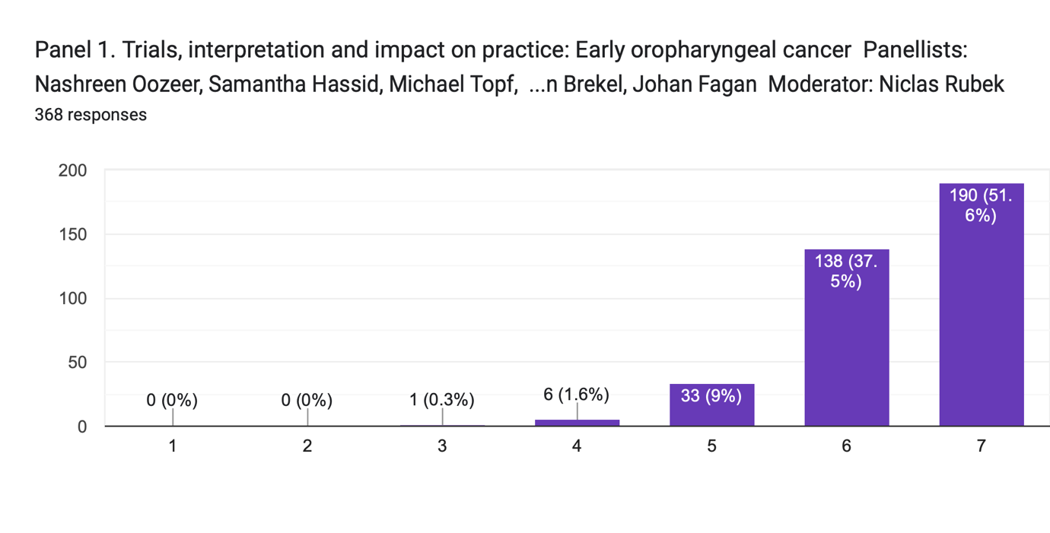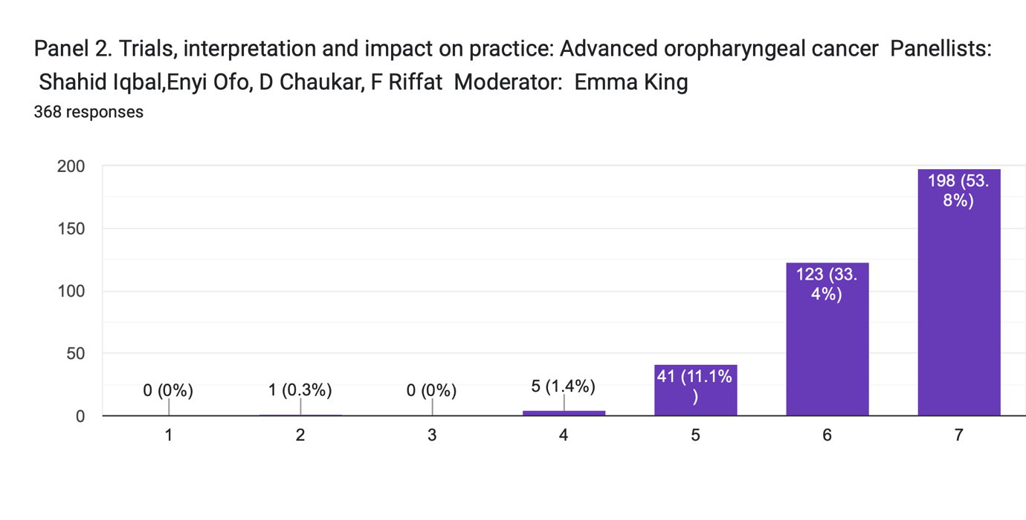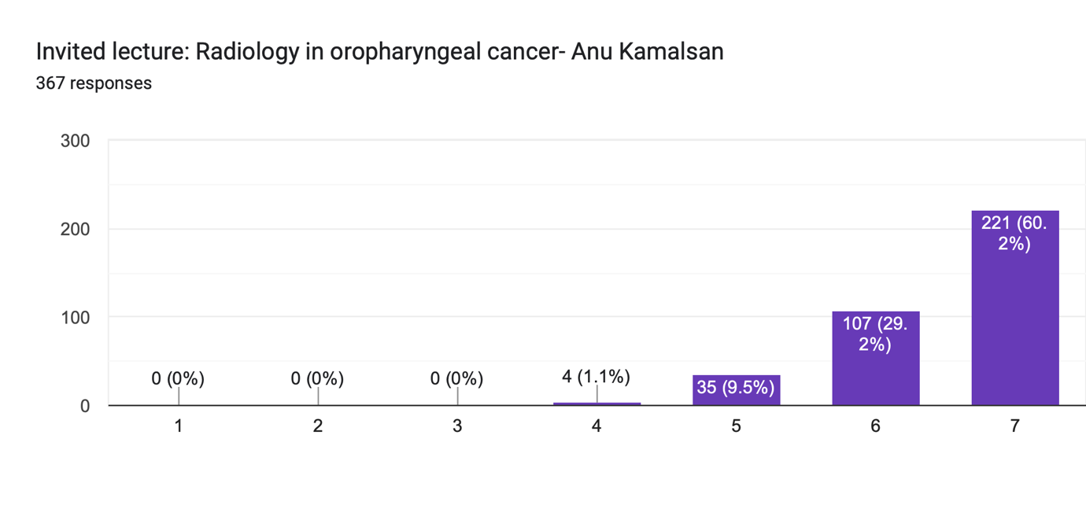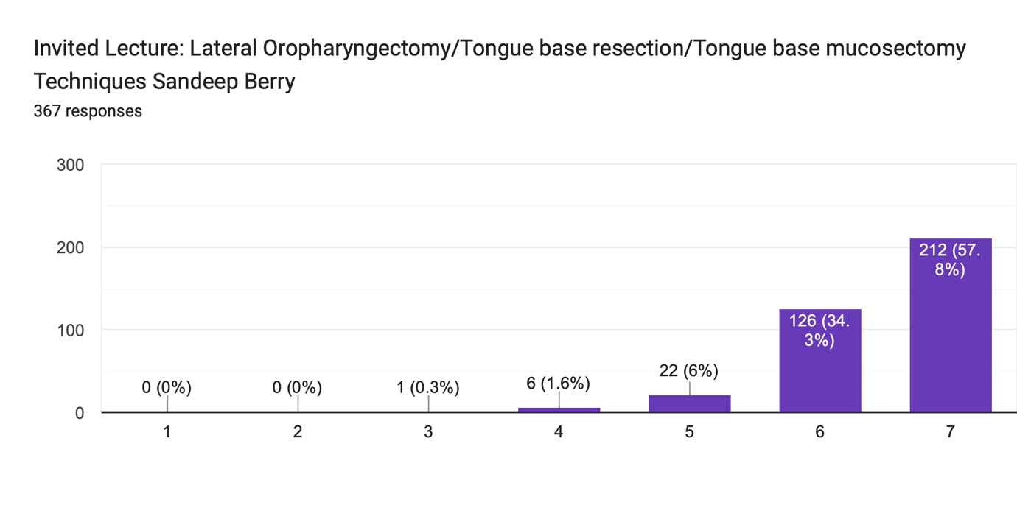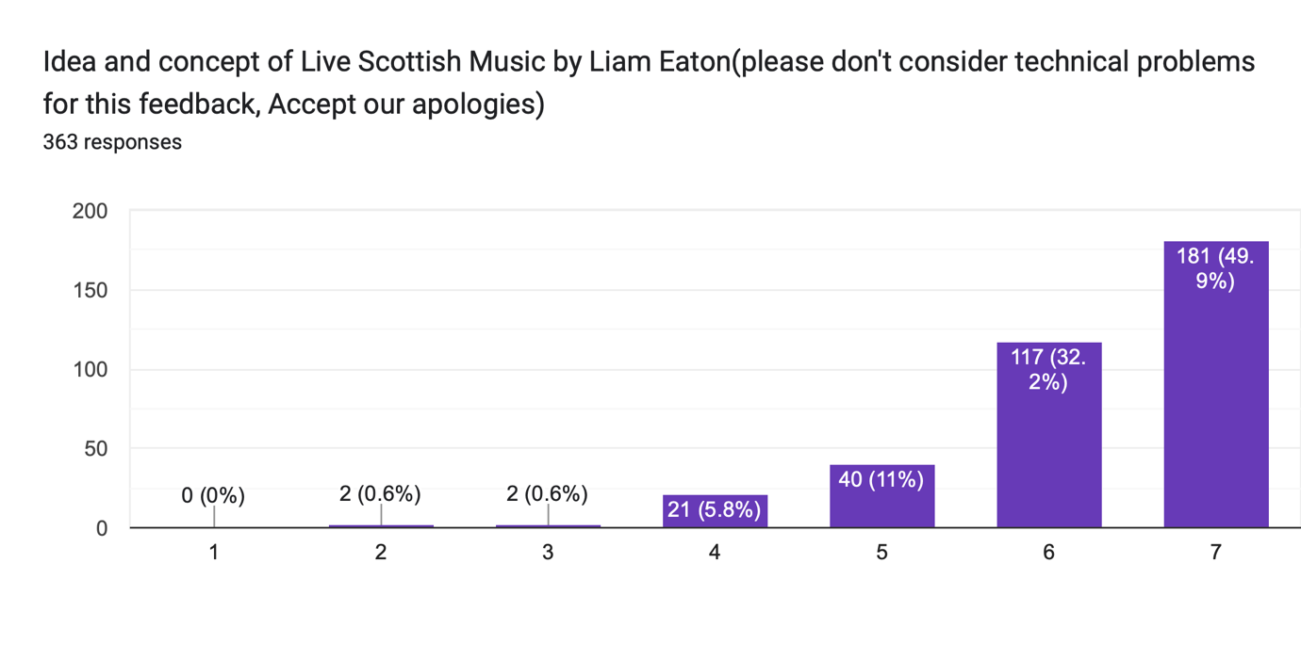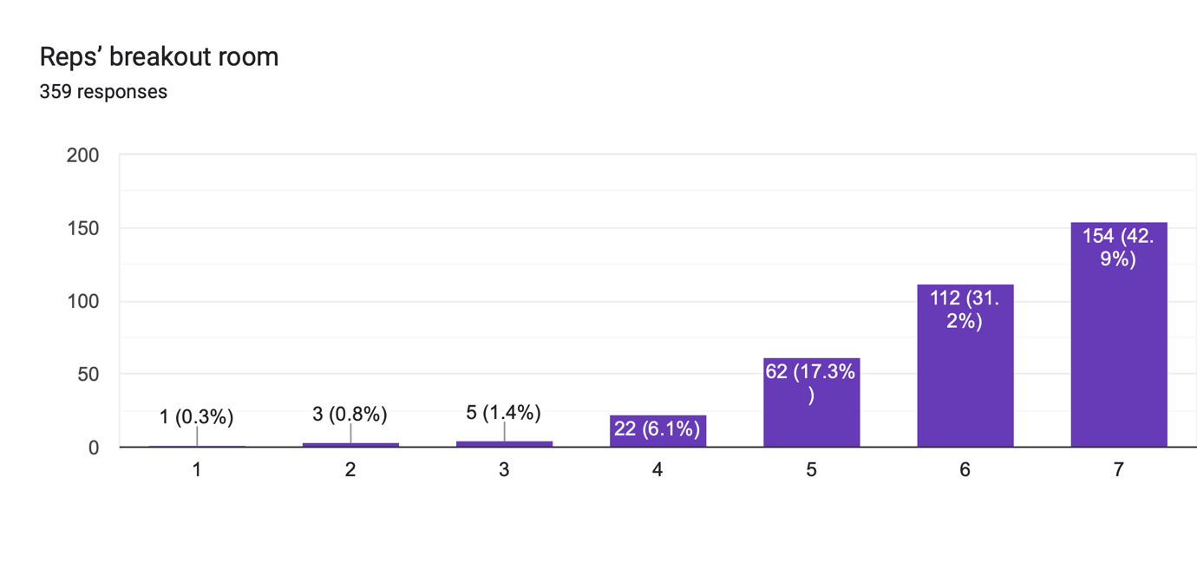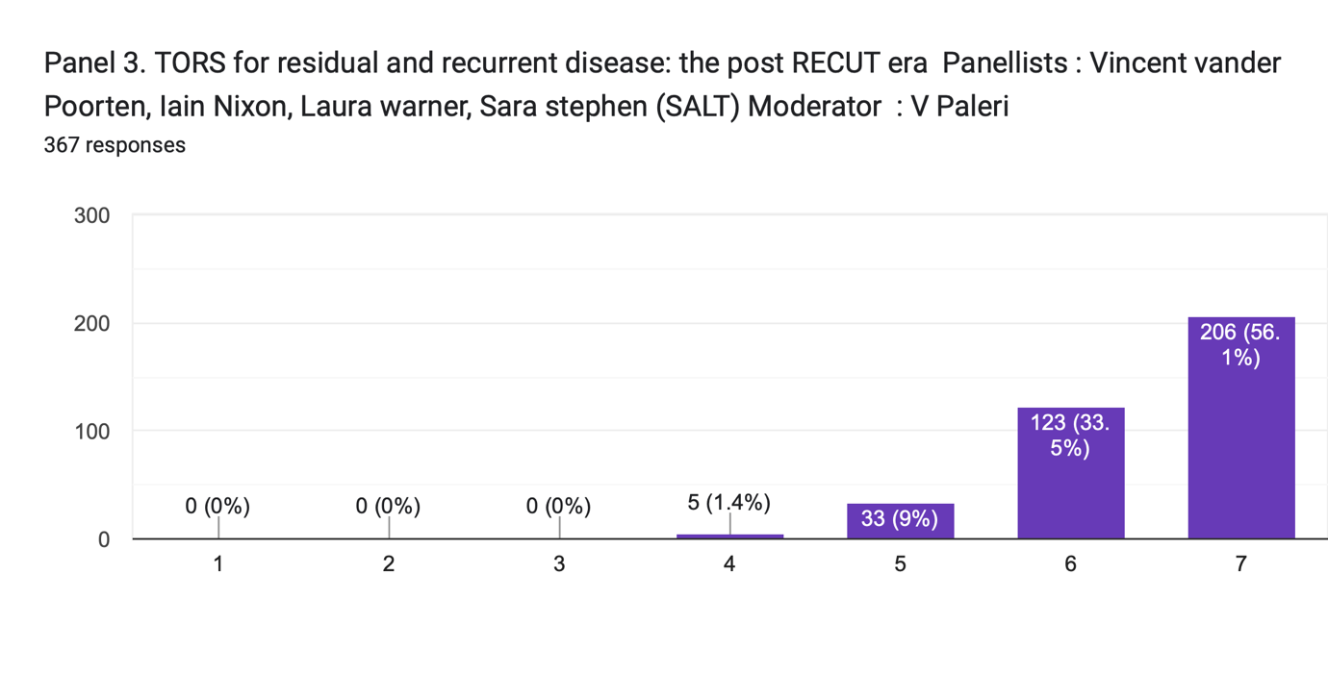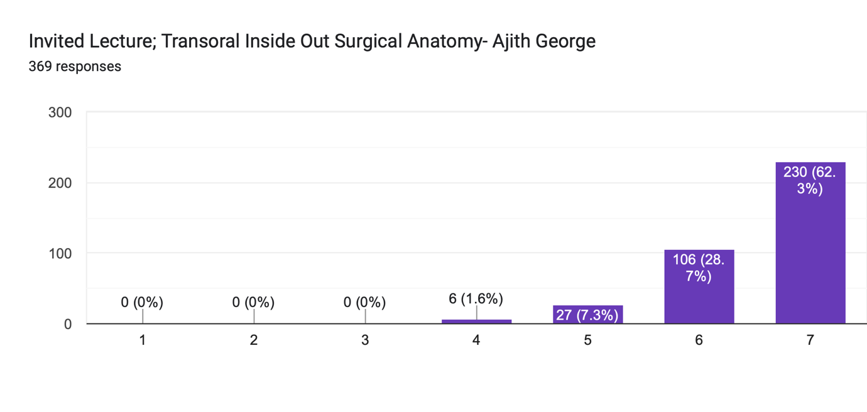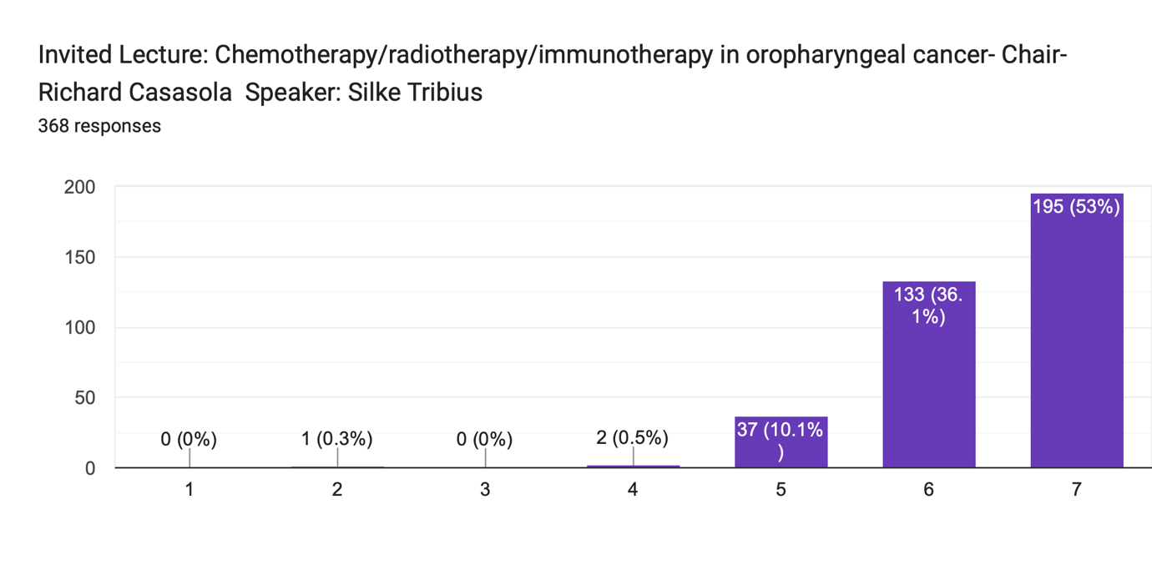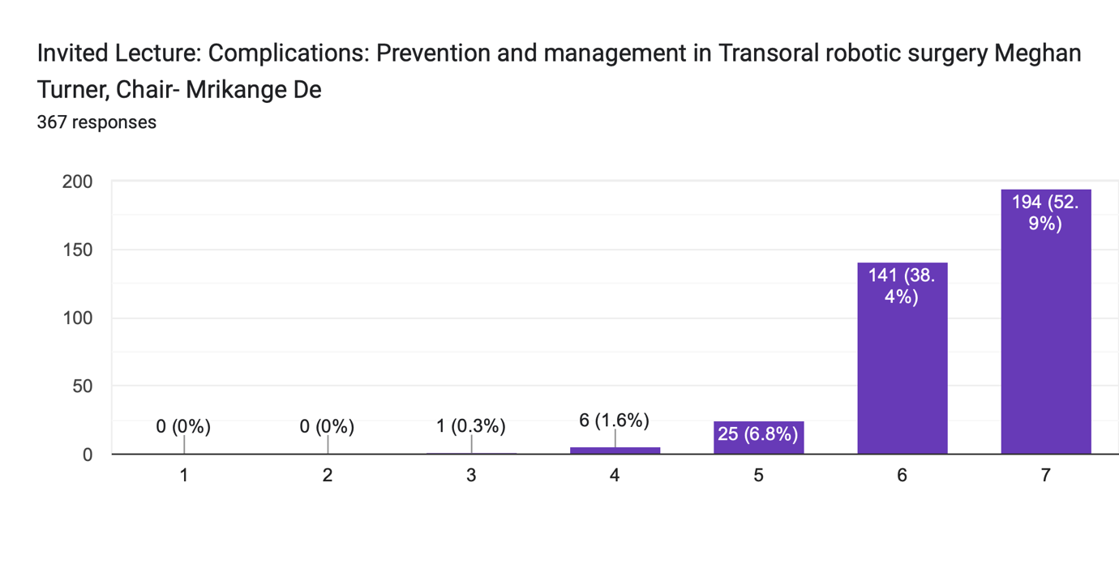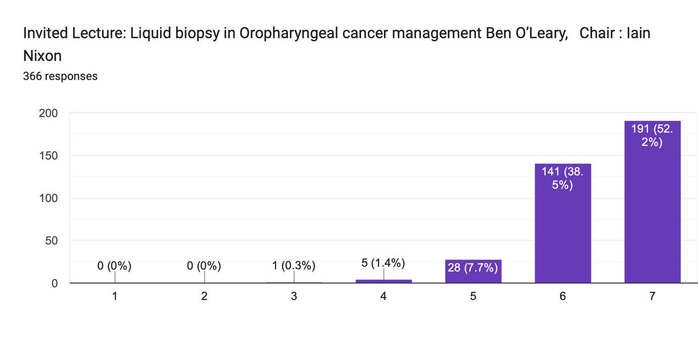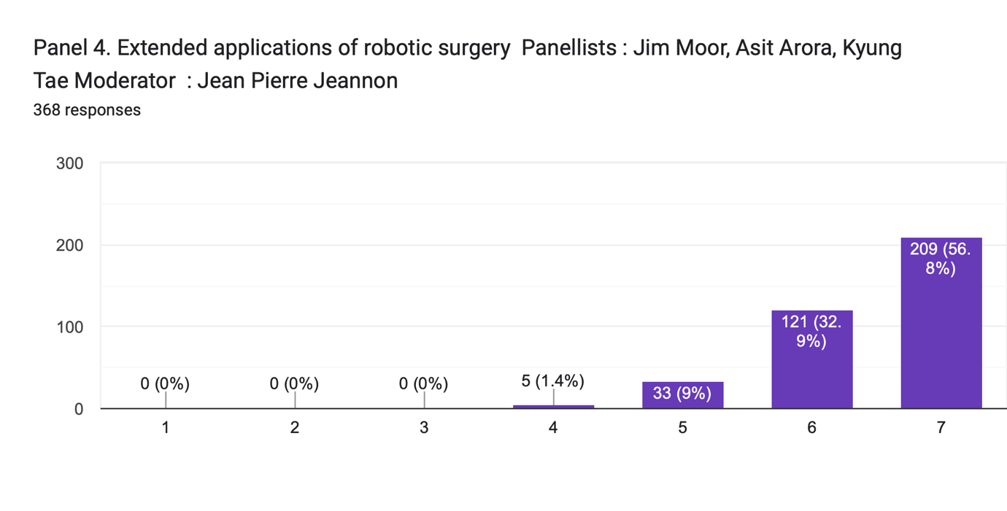
Any Positive comments 164 responses:
Excellent
Fabulous session it was
Thank you
Organised very well and kept to time. Amazing work to Jai in particular
Well done .
Overall an excellent day
Timing was excellent.
well organized
Great meeting
Have attended your conference for the third time Highly useful
well organised, good to have hybrid settings
Informative and clear messages.
So very grateful for the free virtual opportunity.
Very well organised conference
Well deserved event very informative
Excellent choice of topic
Very comprehensive discussion
well presented, good coverage of topics
Well organised. Nice to have international speakers, however brief. Reasonable cost
very well organized lectures, I enjoyed them.
Great day thanks. Anatomy lecture outstanding.
Well done Mr Manik and team. Excellent educational event
Very well run and interesting lectures
All good
Always happy to attend
Fantastic Conference
Excellent presentation
Excellent meeting
Thank you for a great and informative conference.
Very well organized
Very informative and upto date
Thank you for doing this event
Excellent meeting
Perfect organisation
Very well organized
Very concise
Great content.
excellent meeting
Its been honour to participate in your workshop, its always been very informative and give new insight
Learn lots of new things
no
Looking forward for more such sessions.
Good workshop
Many thanks, great idea for a hot topic
It was a great day to hear from all the great speakers.
An excellent day overall - first class talks and superb CPD opportunity, the hybrid format seemed to work very well
Very specialised area
High quality teaching from experienced colleagues
very well organised. Super selection of invited lectures. plenty of topics
Excellent program
This is my second time to attend this conference, well done and thank you for excellent arrangement and presentation
Very well organised, very high standard of talks, great venue
Well organized conference
Thanks for organising an interesting meeting
Very well organised event, thorough lectures with very useful learning points that will form the basis of quality improvement in my own trust, specifically relating to the applied applications of robotic surgery lecture. Having just sat MRCS part A, was great to contextualise some of my ENT revision in a more advanced context. Thank you for hosting a fantastic event.
Organize the same next year
Well organised and structured up to date teaching conference, thank you for the great work
Keep on spreading knowledge
N/A Thank you
Very useful
Keep spreading knowledge
Excellent conference, looking up for more.
Well organized and covered all relevant aspects. Excellent panelists and moderators
Very informative & well organized Great job!
Excellent course
One of the best meetings ever I attended
Fantastic day. Thank you
Well worth the effort of attending.
Excellent meeting, covered many important topics
Wonderful topic selection and clinic oriented
Very nice presentation
This conference is very productive for cosultant and resident these conference should be continue
A really well organised conference with expert panellists and speakers.
Mr George’s anatomy session was incredible
Well organised. Many useful tips
Perect organisation
enlightening day
Nicely organised
It was very focussed and informative.
Best plateform for teaching
Keep up the good work!
Very good
Everything was good and well organized
Great content by expert faculties!
Thank you
Very informative lecture
It was well managed even virtually. Wishing someday to attend it on live.
Excellent work and update a new information
Excellent work and topic covered.
It was a very good sharing, i would love to hear more
Awesome
I really enjoy every single minte in the conference good luck and i hope to see next time face by face
Waiting for another session eagerly.
Great work.... need more such in future
Fab day. So much research in the area, great opportunity to come together to discuss clinical research findings and application to clinical management. great mix of trial data alongside 'clinical experiences'
Excelent meeting
Wonderful organisation and rich content
Well organised and informative
This was an excellent day. To hear from so many experts in one day was a privilege. I liked that the earlier lectures set the scene for oropharyngeal cancers bringing students like myself up to speed so I could appreciate the rest of the talks more. There was also context about surgical developments around the world, I noted down clinical trials of interest which help my learning - I particularly enjoyed the MDT discussions in the afternoon.
I had a very clear idea of the place for robotics in head and neck surgery. I also found the medical talks incredibly helpful.
Excellent work and update a new information
Excellent work and topic covered.
It was a very good sharing, i would love to hear more
Awesome
I really enjoy every single minte in the conference good luck and i hope to see next time face by face
Waiting for another session eagerly.
Great work.... need more such in future
Fab day. So much research in the area, great opportunity to come together to discuss clinical research findings and application to clinical management. great mix of trial data alongside 'clinical experiences'
Excelent meeting
Wonderful organisation and rich content
Well organised and informative
This was an excellent day. To hear from so many experts in one day was a privilege. I liked that the earlier lectures set the scene for oropharyngeal cancers bringing students like myself up to speed so I could appreciate the rest of the talks more. There was also context about surgical developments around the world, I noted down clinical trials of interest which help my learning - I particularly enjoyed the MDT discussions in the afternoon.
I had a very clear idea of the place for robotics in head and neck surgery. I also found the medical talks incredibly helpful.
Wealth of expertise. Enjoyable informative discussion
Thank you for organising and arranging to have speakers from all over. I found the entire event to be very informative
Well presented conference
Very good infos
I really appreciate the option of attending online. I live and work in England, so coming to Scotland would be difficult.
Thank you
The radiological anatomy talk was beautifully presented and has definitely enhanced my understanding of the local anatomy.
Well organized and very informative sessions
Thank you for the opportunity to attend virtually, the panel sessions were really great and I learned a lot.
Thank you
Great conference, great panellists
Excellent presentations and arrangements
Excellent range of speakers and their knowledge on the topic was amazing. Loved the use of up to date papers
The conference was a very enjoyable learning experience
Large range of expert speakers, lectures and talks all of high quality. Good use of audio-visual aids throughout majority of presentations.
Very nice experience
Brilliant conference with a lot of knowledge given but was difficult to take all in so will be helpful if we can have a recording please
Really well organised conference. Really enjoyable
Very interesting, opened my eyes to a lot of topics
Really well organised with very exciting new research
Very p
Fabulous session it was
Good
It's really nice to receive knowledge from world class surgeon
Looking forward to more frequent conferences
Keep up the good work Mr Jai and the team. Nandri
Thank you for the informative sessions!
Kindly have more such events
Well organised.
Great conference
Very interesting!
Keep it up.. Excellent
Well rounded panel, very interesting discussion
Excellent conference all round
very informative
Good range of topics presented
GOOD
Excellent Meeting
Thank you for the very beneficial lecture
The meeting was organised well .We enjoyed the academic feast
Learnt a lot, enjoyed getting to know the international ENT community
It was nice and informative
Thank you for a very interesting conference.
Excellent
Everything was very well explained and was very interactive.
Very well organised. Especially the lecture on radiology was very good.
Really well organised, and appreciate not charging a fee to attend, thanks
Well organised
Thoroughly enjoyable lectures, excellent speakers
Anu Kamalsan - excellent, Sandeep Berry- early experience was good for those of us who want to start
Well organised. Looking forward for the next year's as well!
Great mix of presentations and interesting topics
Outstanding meeting
Good range of speakers and the different approaches to similar topics was excellent. The surgical anatomy lecture alongside the 3D reconstruction was absolutely exceptional!
A brilliant meeting. Will Endeavour to attend annually
"Wonderful day, if a bit advanced for me. But very interesting and well organised.
Many thanks"
Good selection of patients for discussion, well organised conference
Very good day and well organised. Excellent to have the option to join remotely. This is the future of meetings
please organize more like this
Excellent, thanks!
excellent topics
Great conference, well organised and knowledgable speakers.
Excellent, informative meeting

Any constructive comments/things to improve 91 responses:
N/A
Keep it up
None
Panel discussions needed more team so perhaps reduced lectures and more time for panels
The IT /presentation side of things didn't run particularly smoothly
Opening outside with this might have been good It just hindered mingling and conversation a tad. Maybe fiddle might be better next time.
Thank you so much
none
Reduce technical glitch
Please deal with IT issues so that presentation is ready.
Nil of note
Virtual food & drink :-)
Really well organised thanks. Polls didn’t work for me - may just have been technical thing. Maybe include a radiologist from a mature tors programme
Too long
More interaction
Do this events regularly
.
Need to be cognizant of prayer times on Friday for some of the attendees
Just technical issues. Minor only.
If you can give some time to participant to speak i think it will be nice
no
Upload of sessions on YouTube for revision views.
More questions interaction will be great with Slido
Timings on the programme seemed a bit different to those on the day but otherwise no other issues
Online chat function was deactivated. Online Polls not possible
Panel 1 moderation was not good - they ran out of time with speakers still left to present. All other panels were excellent.
NA
Provide video so that participants could watch many times
Many thanks for continued improvement of this event
N/A Looking forward to next one
Try to improve the connection problems
Thank you sincerely
There was no specific registration process and name badges would have helped.
None
All things are good some defincy in network problem hope these will be improve
Nona
good organiation and very informative
There should be more question answer session
panel discuss could have been better.
These conference should be held in every month
More explanation
need an active discussion
Although prevented travelling using video attendance felt less participative.
Please organize one on thyroid malignancy and surgeries.
I think because of the time zone in can be hard for some region to follow the conference especially because of the long hour presentation
All good
No such comments.
Send recorded lectures to participants or link for access to view
One of the afternoon presenters made a joke/sarcastic remark about a female patient being able to return to her life of unpaid housework duties after her cancer treatment. This was disrespectful to all unpaid caregivers (but particularly women) who I'm sure we all agree undertake vital work in our society.
More basic/ general lectures on the suject
More interaction with online attendees in the future.
Everything went ok
Speaker confidence with the technology/IT on the day (only in some cases)
Looking forward to next one
nil
Difficult to conduct a conference virtually IE technical issues. Practise makes perfect for technology use.
Please upload videos on YouTube
Nil
I would suggest spacing out over more than one day - very interesting topics such as these can be done justice in this way
More description needed
Useful sessions esp for juniors. Thank you
Kindly have more such events
Will be nice if the presentations can be emailed oit
Definitely above my level but still interesting
Appreciated the option for hybrid attendance
Plz make lectures available on you tube
Include all the professional delegates
The sessions could have been more interactive
NOTHING
Please share the recording on YouTube to revise some of the details mentioned in the panel
To stick to time please, there was a late finish and constant delay
Live surgical workshop can be planned for a half day
More examples
Nil
Make sessions more interactive if possible.
Great work. Keep it coming.
Excellent organisation overall- online course is god send for those with time constraints and parental responsibilities
Tumors in Children
Chat function was a problem on the technical side, don't know what could have been done to fix that
A real registration desk and name tags would have been helpful
Please continue virtual participation option
More sessions on technical aspects of robotic surgery would be good including operative videos and explanations
maybe can meet physically since covid19 reducing now

Executive summary on Meeting:
Feedback grade 1-7 (1- very bad, 4-Neutral, 7- Excellent)
Organisation and fulfilling aim- 99.7% positive feedback, remaining neutral, Nil negative feedback
Speaker/ panel-98% positive feedback, remaining neutral, Nil negative feedback
Polls, Pipe entertainment, reps- 93% positive feedback, 5% neutral, 2% negative feedback

